Morphological Operations Using Opening
Experiment No: 31
Aim
To perform the morphological opening operation on an image using OpenCV in Python.
Tools Required
- Python 3.x
- OpenCV (cv2)
- NumPy
- VS Code / PyCharm / Jupyter Notebook
- Input image (image.jpg)
Theory
Opening is a morphological operation that is performed by applying erosion followed by dilation.
Opening is mainly used to:
- Remove small unwanted objects or noise.
- Smooth the boundaries of objects.
- Separate objects that are connected by thin regions.
Procedure
- Install OpenCV and NumPy:
Bash
pip install opencv-python numpy
- Read the input image using OpenCV.
- Convert the image to grayscale.
- Create a structuring element (kernel).
- Apply morphological opening using cv2.morphologyEx().
- Display the original and opened images.
- Save the resulting image
Code
import cv2
import numpy as np

# Read the image
image = cv2.imread("image.jpg")

# Check if image is loaded
if image is None:
print("Error: Image not found!")
exit()

# Convert image to grayscale
gray = cv2.cvtColor(image, cv2.COLOR_BGR2GRAY)

# Create a structuring element
kernel = np.ones((5, 5), np.uint8)

# Perform morphological opening
opened = cv2.morphologyEx(gray, cv2.MORPH_OPEN, kernel)

# Display original image
cv2.imshow("Original Image", gray)

# Display opened image
cv2.imshow("Opening Operation", opened)

# Save the opened image
cv2.imwrite("opened_image.jpg", opened)

cv2.waitKey(0)
cv2.destroyAllWindows()
Output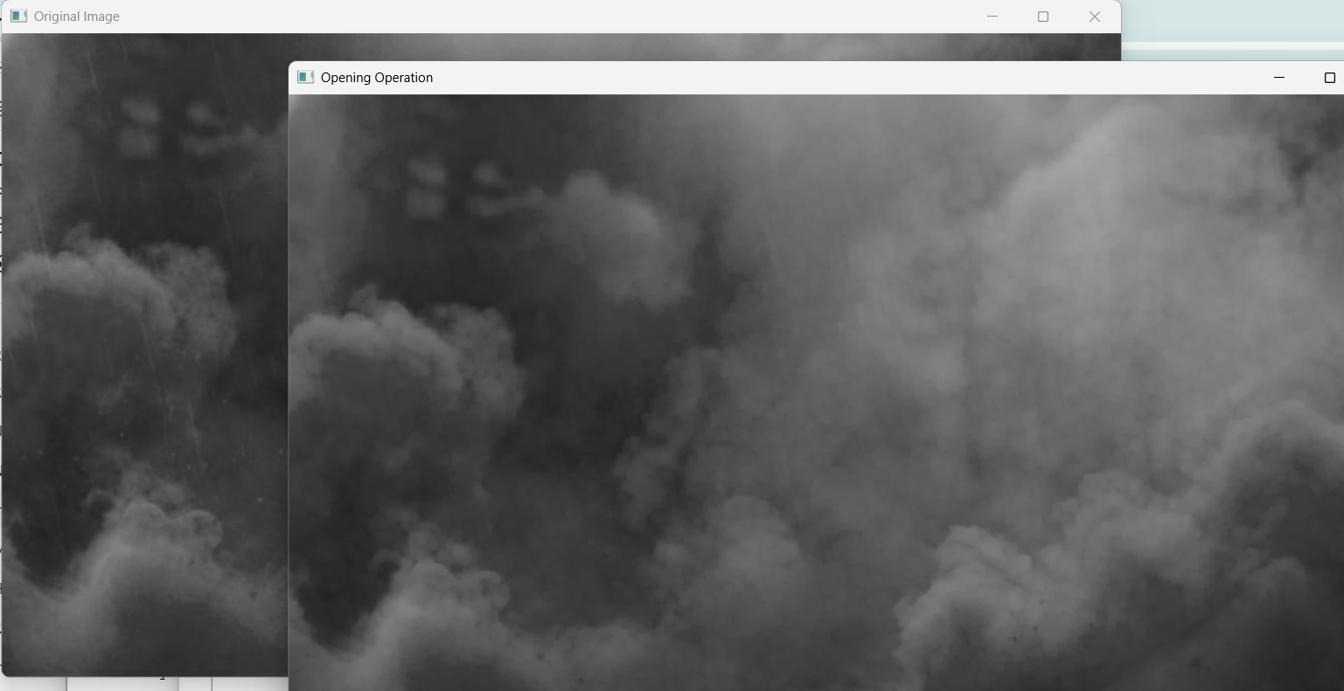
Result
The morphological opening operation was successfully performed using OpenCV. The image was first eroded and then dilated using a 5 × 5 structuring element, successfully removing small unwanted regions and smoothing the image.

